1. A use case specification document for all use cases.

**Use Case Name: Start Game**

Optimistic Flow:

1. Player opens application
2. Player presses ‘Start Game’

Pragmatic Flow:

Condition 1: Application doesn’t open

1. Player sends email to app creators with relevant information
2. Player waits for response
3. Player continues regular flow at step 1

**Use Case Name: Move Character**

Optimistic Flow:

1. Player uses ‘a’ and ‘d’ keys to move left and right
2. Player ‘w’, ‘space’,  ‘s’, and  ‘ctrl’ keys to jump and crouch

Pragmatic Flow:

N/A

**Use Case Name: Change Character**

Optimistic Flow:

1. Player uses ‘q’ and ‘e’ to cycle through characters

Pragmatic Flow:

N/A

**Use Case Name: Change Settings**

Optimistic Flow:

1. Player presses ‘esc’ to open the options menu
2. Player will adjust the options to their preferences

Pragmatic Flow:

N/A

**Use Case Name: Use Special Ability**

Optimistic Flow:

1. Player presses ‘f’ to use special ability

Pragmatic Flow:

1. A UML use case diagram modeling all of the use cases.

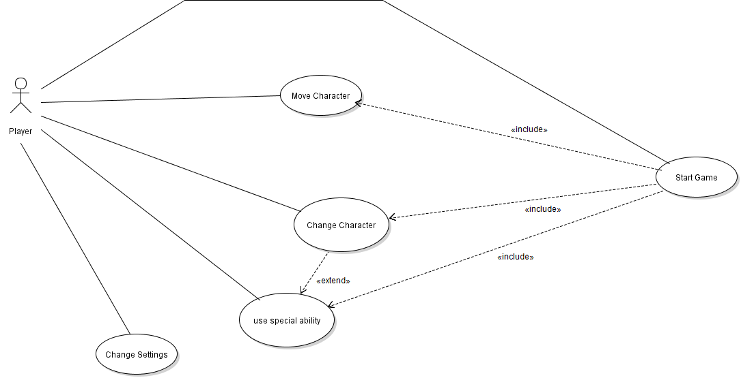

1. A system sequence diagram for each use case.

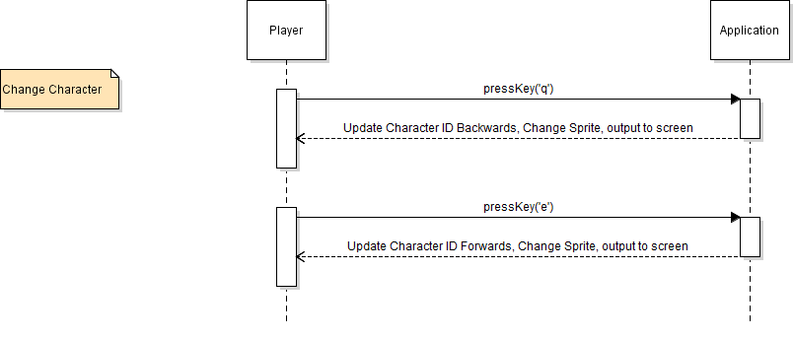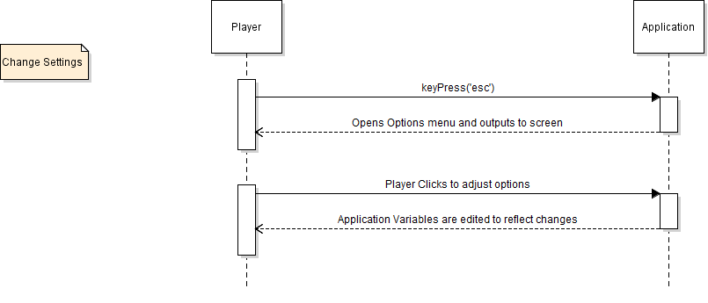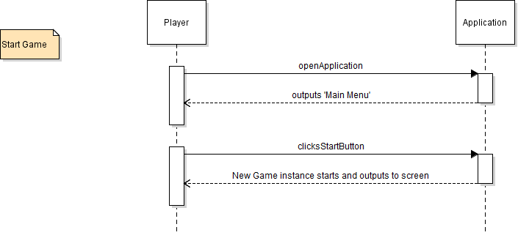



Move Character

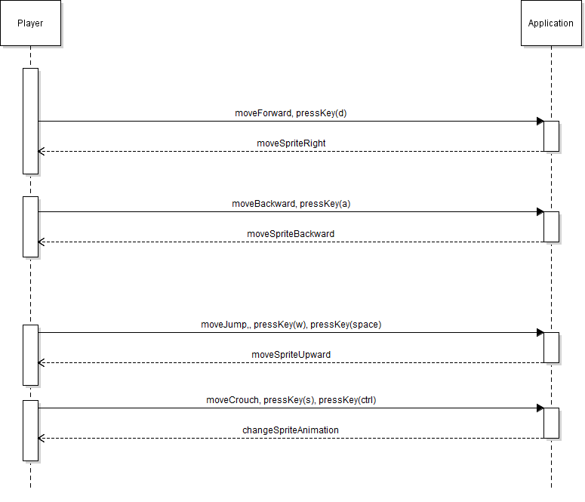

1. A domain-level diagram for the whole system, expressed as a UML class diagram

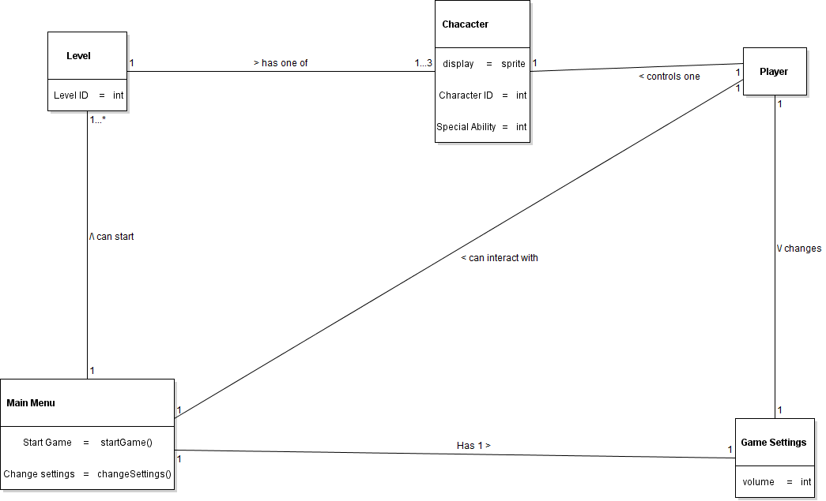

1. A class diagram for your system.